Explorers Class (FSU) Core Nursery Rhymes 2021-22

We love singing in Explorers Class and really value and prioritise spending time teaching our children good quality, classic nursery rhymes. Not only do nursery rhymes introduce children to the idea of storytelling, promote social and auditory skills and boost language development but they are also an early predictor of literacy skills. This year we have a short topic focusing on nursery rhymes just before and after half term where we will introduce children to four key nursery rhymes. Like our Core Books, these nursery rhymes will be repeated throughout the year so the children can not only repeat them but also understand the vocabulary in them and what they are about.
Here are the Core nursery rhymes we will be focusing on with our children this academic year and the words for you to be able to say them with your child;

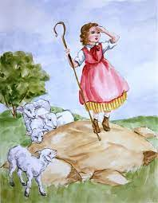
Little Bo-Peep
Little Bo-Peep has lost her sheep,
And doesn’t know where to find them;
Leave them alone, and they'll come home,
Wagging their tails behind them.

Humpty Dumpty
Humpty Dumpty sat on a wall
Humpty Dumpty had a great fall
All the king's horses and all the king's men
Couldn't put Humpty together again.

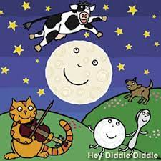
Hey Diddle, diddle
Hey, diddle, diddle, the cat and the fiddle
The cow jumped over the moon
The little dog laughed to see such fun
And the dish ran away with the spoon

Baa Baa Black sheep
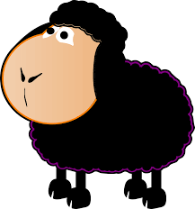
Baa, baa, black sheep
Have you any wool?
Yes, sir, yes, sir
Three bags full
One for the master
And one for the dame
And one for the little boy
Who lives down the lane.
Thank you said the master
Thank you said the dame
Thank you said the little boy who lives down the lane.

